Final Project Documentation

Traffic Accidents Data Analytics

Data Preprocessing Script

General Overview

This document outlines the data preprocessing steps applied to the Traffic Accidents Dataset (209,306 records x 24 columns) using the CLEAN Framework. All steps were performed in Microsoft Excel.

C - Conceptualize The Data

Objective: Understand the dataset structure, data types, and overall integrity before performing modifications.

Actions Performed

• Opened the CSV dataset in Microsoft Excel

• Verified the dataset dimensions: 209,306 rows x 24 columns

• Inspected all columns using filters and column validation

• Reviewed data types and checked numeric ranges using Excel formulas

Validation Results
Column | Valid Range | Status
crash_hour | 0-23 | Pass
crash_day_of_week | 1-7 | Pass
crash_month | 1-12 | Pass
num_units | 1-11 | Pass

Issue & Resolution

Issue: The crash_date column was stored as plain text instead of a valid datetime format.

Resolution: Used Format Cells > Date/Time in Microsoft Excel to convert the column into a proper datetime format.

L - Locate Solvable Problems

Objective: Identify missing, null, or incomplete data entries.

Actions Performed

• Applied the COUNTBLANK() formula to all columns

• Verified that no fully blank cells existed

• Used the COUNTIF() function to identify UNKNOWN values in categorical columns

UNKNOWN Value Counts
Column | UNKNOWN Count
road_defect | 34,426
roadway_surface_cond | 12,509
weather_condition | 6,534
traffic_control_device | 4,455
lighting_condition | 4,336
trafficway_type | 1,060

Decision: Following the CLEAN Framework principle that "perfect data is not always achievable," all UNKNOWN values were classified as unsolvable missing data and retained to preserve dataset authenticity and integrity.

E - Evaluate Unsolvable Issues

Objective: Remove duplicate records that could negatively affect analytical accuracy.

Actions Performed

• Used Data > Remove Duplicates in Excel

• Selected all 24 columns to detect fully identical rows

Result
Metric | Value
Duplicate rows removed | 31
Original record count | 209,306
Final record count | 209,275

A - Augment The Data

Objective: Standardize formatting and correct inconsistent textual values.

Step 1: Whitespace Trimming

Used the TRIM() function across all text columns to remove unnecessary leading and trailing spaces.

=TRIM(A2)

Step 2: Abbreviation Expansion

The intersection_related_i column contained abbreviated values Y and N. Expanded using Find & Replace (Ctrl + H):
Original | Replaced With
Y | YES
N | NO

Step 3: Title Case Standardization

Most categorical columns were in all capital letters. The PROPER() function was used to convert them to Title Case:

=PROPER(B2)

Applied to the following columns:

• traffic_control_device

• weather_condition

• lighting_condition

• first_crash_type

• trafficway_type

• alignment

• roadway_surface_cond

• road_defect

• crash_type

• damage

• prim_contributory_cause

• most_severe_injury

N - Note and Document

Objective: Standardize data formats and improve dataset readability for analysis.

Step 1: Injury Column Standardization

The following columns were stored as decimals despite representing whole-number counts:

• injuries_total

• injuries_fatal

• injuries_incapacitating

• injuries_non_incapacitating

• injuries_reported_not_evident

• injuries_no_indication

Resolution:

• Used Format Cells > Number (0 Decimal Places)

• Replaced blank numeric cells with 0 using Find & Replace

Step 2: Added Readable Time Columns

The dataset stored crash_day_of_week (1-7) and crash_month (1-12) as numbers. Two new columns were added for readability:

crash_day_name formula:

=IFS(W2=1,"Monday",W2=2,"Tuesday",W2=3,"Wednesday",W2=4,"Thursday",W2=5,"Friday",W2=6,"Saturday",W2=7,"Sunday")

crash_month_name formula:

=IFS(X2=1,"January",X2=2,"February",X2=3,"March",X2=4,"April",X2=5,"May",X2=6,"June",X2=7,"July",X2=8,"August",X2=9,"September",X2=10,"October",X2=11,"November",X2=12,"December")

Preprocessing Summary
CLEAN Step | Action Performed | Excel Tool | Issue Type | Resolution
Conceptualize | Converted crash_date to datetime | Format Cells > Date/Time | Incorrect data type | Fixed
Locate | Identified UNKNOWN values | COUNTIF() | Missing data | Retained
Evaluate | Removed duplicate rows | Remove Duplicates | Duplicate records | Fixed
Augment | Removed whitespace | TRIM() | Formatting inconsistency | Fixed
Augment | Expanded Y/N values | Find & Replace | Abbreviations | Fixed
Augment | Converted text to Title Case | PROPER() | Formatting inconsistency | Fixed
Note | Converted injury columns to integers | Format Cells > Number | Incorrect numeric format | Fixed
Note | Added readable day/month columns | IFS() Formula | Readability issue | Enhanced

Insights and Recommendations

The following insights and recommendations are derived from the analysis of 209,275 traffic accident records covering the years 2021–2023. Each insight is grounded in patterns observed in the data and is paired with actionable, real-world recommendations for traffic safety stakeholders.

Dataset at a Glance
Metric | Value
Total Records Analyzed | 209,275
Total Injuries | 80,091
Fatal Injuries | 389
Incapacitating Injuries | 7,974
Crashes at Intersections | 199,294 (95.2%)
Crashes with Over $1,500 Damage | 147,294 (70.4%)

Insight 1: Afternoon Rush Hours Are the Highest-Risk Period
Finding
Crash frequency peaks sharply between 3:00 PM and 6:00 PM, with the single highest hour being 5:00 PM (16,095 crashes). The afternoon window from 2:00 PM to 6:00 PM accounts for a disproportionately large share of all recorded accidents compared to any other time block.

Time Block | Crash Count | Risk Level
12:00 AM – 5:00 AM | ~17,574 | Low
6:00 AM – 9:00 AM | ~25,453 | Moderate
10:00 AM – 1:00 PM | ~41,762 | Moderate–High
2:00 PM – 6:00 PM | ~74,780 | Highest
7:00 PM – 11:00 PM | ~37,406 | Moderate

Real-World Context
This pattern aligns with evening rush hour commuting, school dismissal times, and increased commercial deliveries in the late afternoon. Driver fatigue and impatience after a full workday likely contribute to reduced attention and risk-taking behavior.

Recommendation
• Increase traffic enforcement presence (police, speed cameras) along major corridors during 2:00 PM – 6:00 PM.
• Coordinate school zone patrols and crossing guards to align with peak dismissal hours (2:30 PM – 4:00 PM).
• Deploy dynamic message signs warning of congestion and encouraging safe following distances during peak hours.

Insight 2: Intersections Are the Primary Crash Location
Finding
An overwhelming 95.2% of all crashes (199,294 out of 209,275) occurred at or near intersections. The top crash types — Turning (64,150), Angle (52,243), and Rear End (42,007) — are all characteristic of intersection-related collisions.

First Crash Type | Count | % of Total
Turning | 64,150 | 30.7%
Angle | 52,243 | 25.0%
Rear End | 42,007 | 20.1%
Sideswipe Same Direction | 20,114 | 9.6%
Pedestrian | 8,995 | 4.3%
Pedalcyclist | 5,335 | 2.6%

Real-World Context
Intersections create conflict points where vehicles traveling in multiple directions must navigate simultaneously. Turning movements and angle crashes are particularly dangerous as they often involve perpendicular impact forces, increasing injury severity risk.

Recommendation
• Audit high-frequency intersection crash locations and consider installing or upgrading traffic signals, protected left-turn phases, or roundabouts.
• Implement red-light camera enforcement at intersections with high rates of signal disregarding (14,590 recorded cases).
• Review sight-line obstructions (parked vehicles, overgrown vegetation) at problematic intersections.
• Add dedicated pedestrian and cyclist crossing phases at intersections with high pedestrian/cyclist crash counts.

Insight 3: Failure to Yield and Following Too Closely Are Leading Causes
Finding
Among identifiable causes, Failing to Yield Right-of-Way (42,909) and Following Too Closely (19,074) are the top two confirmed contributory causes. Disregarding Traffic Signals (14,590) and Improper Turning/No Signal (12,642) round out the top causes. Notably, 58,310 crashes were marked as "Unable to Determine," representing a significant data gap.

Primary Cause | Count
Unable to Determine | 58,310
Failing to Yield Right-of-Way | 42,909
Following Too Closely | 19,074
Disregarding Traffic Signals | 14,590
Improper Turning/No Signal | 12,642
Failing to Reduce Speed to Avoid Crash | 10,675
Improper Overtaking/Passing | 8,302
Disregarding Stop Sign | 6,746

Real-World Context
Failing to yield and following too closely are behavioral issues strongly linked to driver inattention, distracted driving, and aggressive driving habits. These are preventable causes that respond well to public education and enforcement campaigns.

Recommendation
• Launch targeted public awareness campaigns focusing on right-of-way rules and safe following distances, particularly aimed at new and young drivers.
• Introduce automated tailgating detection cameras on high-speed corridors where rear-end crashes are frequent.
• Require improved driver education curriculum coverage of intersection rules, yielding, and turn signaling.
• Work with data collectors to reduce the 27.8% 'Unable to Determine' rate by improving crash report standardization and officer training.

Insight 4: Clear Weather Conditions Dominate Crash Records
Finding
Contrary to common assumption, 78.7% of all crashes (164,673) occurred under clear weather conditions. Rain accounted for only 10.4% (21,702 crashes), and snow for 3.3% (6,869 crashes). However, rain and snow crashes likely carry higher severity per incident due to reduced road friction.

Weather Condition | Count | % of Total
Clear | 164,673 | 78.7%
Rain | 21,702 | 10.4%
Cloudy/Overcast | 7,532 | 3.6%
Snow | 6,869 | 3.3%
Unknown | 6,534 | 3.1%
Other/Fog/Freezing Rain | 1,497 | 0.7%

Real-World Context
Clear weather may lead drivers to feel overconfident, resulting in less cautious behavior. While adverse weather increases crash risk per mile driven, the sheer volume of clear-weather driving means absolute crash numbers are much higher on good-weather days.

Recommendation
• Avoid over-focusing safety campaigns solely on adverse weather — promote year-round safe driving habits regardless of conditions.
• During rain and snow events, activate variable speed limit systems and advisory messages to prompt speed reduction.
• Ensure road maintenance (pothole repair, line repainting) is prioritized before high-traffic seasons to reduce surface-related crash risk.

Insight 5: Darkness Significantly Contributes to Severe Crashes
Finding
While most crashes (64.1%) occurred in daylight, crashes occurring in darkness — particularly on unlighted roads — are associated with higher injury severity. Darkness on unlighted roads (7,436 crashes) presents a more dangerous environment than darkness on lighted roads (53,375 crashes). Additionally, dusk and dawn periods account for 10,045 crashes combined, representing transitional low-visibility conditions.

Lighting Condition | Count
Daylight | 134,083
Darkness, Lighted Road | 53,375
Darkness (No Lighting) | 7,436
Dusk | 6,322
Dawn | 3,723
Unknown | 4,336

Real-World Context
Poor lighting reduces driver reaction time and makes pedestrians and cyclists less visible. Crashes in darkness on unlighted roads — though fewer in number — are more likely to result in serious injury or fatality due to higher speeds and reduced hazard visibility.

Recommendation
• Identify and prioritize streets with high crash rates in darkness for streetlight installation or upgrades.
• Implement high-visibility pedestrian crosswalk lighting at intersections where pedestrian crashes occur frequently at night.
• Increase nighttime patrol and DUI enforcement during late-night hours (10:00 PM – 3:00 AM) when impaired driving risk is highest.
• Encourage use of high-visibility clothing and reflective gear in public safety campaigns targeting pedestrians and cyclists.

Summary of Insights and Recommendations
Insight | Key Finding | Priority Recommendation
1. Peak Hours | Crashes peak 3–6 PM (16,095 at 5 PM) | Increase enforcement & traffic management during afternoon rush
2. Intersections | 95.2% of crashes at intersections | Upgrade intersection design, signals, and enforcement
3. Driver Behavior | Failing to yield = 42,909 crashes | Driver education campaigns and automated enforcement
4. Weather | 78.7% of crashes in clear weather | Year-round safe driving campaigns, not just adverse weather
5. Lighting | 7,436 crashes in unlit darkness | Streetlight upgrades and nighttime enforcement

Conclusion
The data analysis of 209,275 traffic accident records reveals that the majority of accidents are not random events — they follow clear, predictable patterns tied to time of day, location, driver behavior, and environmental conditions. The most impactful interventions will target afternoon peak hours, intersection design and control, and driver behavior education. Implementing the recommendations above in a coordinated, data-driven manner has the potential to meaningfully reduce both crash frequency and injury severity across the coverage area.

Data Modeling

Overview
The Traffic Accident Data Model was developed in Power BI using a Star Schema structure. The model consists of one central fact table, Fact_Accidents, connected to several dimension tables that contain descriptive information such as date, cause, crash type, weather, lighting, roadway condition, traffic control, and injury severity.
This structure improves data organization, report performance, and analytical efficiency by allowing faster filtering, aggregation, and visualization of accident-related data.

Fact Table

Fact_Accidents
The Fact_Accidents table stores the measurable accident records and injury-related metrics used for analysis and reporting.
Included measures:
- Accident ID
- Injury Counts
- Damage Information
- Foreign Keys linked to dimension tables

Dimension Tables
Dimension Table | Description
Dim_Date | Stores date, month, day, and hour information
Dim_Cause | Contains primary contributory causes
Dim_Crash_Type | Stores crash classifications
Dim_Weather | Contains weather conditions
Dim_Lighting | Stores lighting conditions
Dim_Roadway | Contains roadway and surface details
Dim_Traffic_Control | Stores traffic control device information
Dim_Injury | Contains injury severity classifications

Relationships
The model uses one-to-many (1:*) relationships between the dimension tables and the Fact_Accidents table. Each dimension table provides filtering and categorization for the accident records stored in the fact table.

Purpose of the Data Model
The data model supports:
- Accident trend analysis
- Injury severity reporting
- Crash type analysis
- Environmental condition analysis
- Forecasting and predictive analytics
The star schema design ensures efficient dashboard performance and simplifies the creation of visual reports in Power BI.
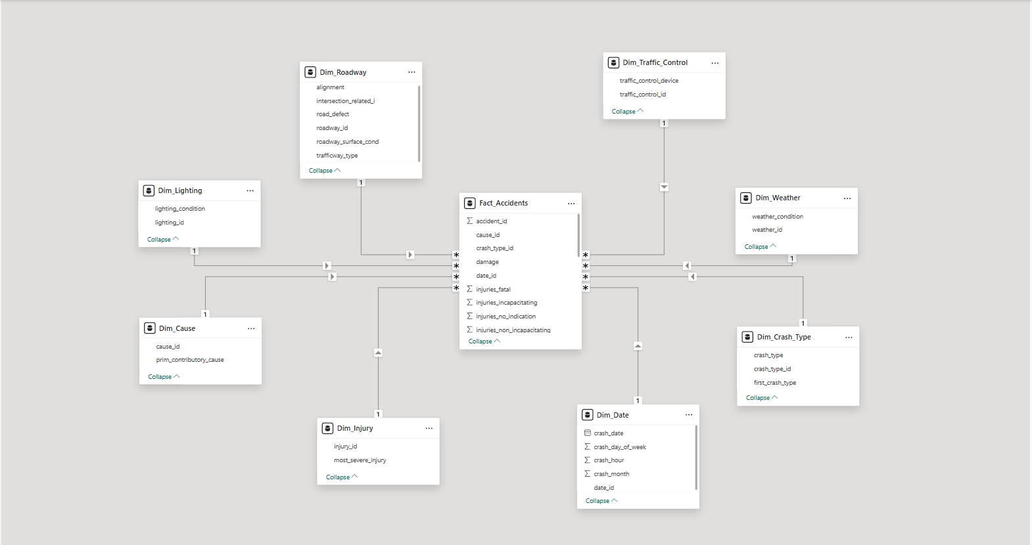

Visualisation/Dashboard
The project utilized the DASH framework to create a structured and user-friendly dashboard environment. The DASH framework was selected because it supports organized data visualization, analytical reporting, and interactive user experience. Through this framework, the dashboard was designed to present complex datasets in a simplified and visually understandable manner.

Purpose
The primary purpose of the Traffic Accidents Analytics Dashboard is to analyze and visualize traffic accident data in order to support data-driven insights and improve road safety awareness. The dashboard aims to:
- Monitor traffic accident trends and frequencies
- Identify accident-prone periods and patterns
- Provide summarized accident statistics through KPIs
- Support analytical reporting using visual representations
- Improve accessibility and understanding of traffic accident information
The dashboard serves as an analytical tool for researchers, students, and decision-makers who require accurate and interactive accident data analysis.

Dashboard Design
The dashboard was designed using a clean and organized layout to ensure clarity, usability, and accessibility. Visual elements were strategically arranged to allow users to quickly understand accident data and trends.
The design includes:
- KPI cards positioned at the top for quick statistical summaries
- Interactive slicers for filtering data dynamically
- Line charts for trend analysis and comparison
- Bar charts for category-based analysis
- Text sections for titles and dashboard descriptions
The dashboard follows visualization principles such as:
- Simplicity and readability
- Consistent layout and formatting
- Effective use of space and alignment
- Interactive data exploration
- Clear presentation of analytical insights
The use of charts and filtering tools allows users to drill down into accident data efficiently and interpret results more effectively.
Dashboard Components
- KPI Cards
The dashboard includes KPI cards that display summarized values such as:
- Total traffic accidents
- Total recorded incidents
- Key statistical summaries
These cards provide users with an immediate overview of important accident metrics.

- Slicer
A slicer component is included to allow users to filter and customize displayed data dynamically based on selected categories or conditions.
- Line Charts
The dashboard contains line charts used to:
- Analyze accident trends over time
- Monitor increases or decreases in accident occurrences
- Compare data across different periods
These charts help visualize temporal patterns and trend movements.
- Clustered Bar Chart
A clustered bar chart is used to compare accident-related categories and display relationships between different accident variables.
- Text and Labels
Textboxes are included for dashboard titles, labels, and descriptions to improve readability and provide context for users.
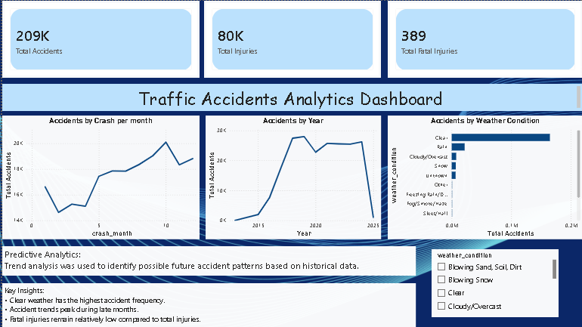
KPIs and Metrics
The dashboard uses Key Performance Indicators (KPIs) and metrics to summarize and evaluate traffic accident data. These include:
- Total Number of Accidents
- Accident Frequency
- Trend Analysis Metrics
- Comparative Accident Statistics
- Time-Based Accident Analysis
- Category-Based Accident Distribution
These metrics allow users to monitor accident performance, identify patterns, and generate analytical insights from the dataset.

DAX/Formulas Used
The dashboard utilizes Data Analysis Expressions (DAX) in Microsoft Power BI to perform calculations and generate dynamic analytical reports.
Common DAX formulas used in the dashboard include:

SUM - Used to calculate total accident values.
Total Accidents = SUM(Accidents[Accident_Count])

COUNT - Used to count the total number of accident records.
Total Records = COUNT(Accidents[ID])

CALCULATE - Used for filtered and conditional calculations.
Filtered Accidents =
CALCULATE(
COUNT(Accidents[ID]),
Accidents[Severity] = "High"
)

DIVIDE - Used to calculate percentages and ratios.

Accident Percentage =
DIVIDE([Filtered Accidents], [Total Accidents]) * 100

DATE FUNCTIONS - Used for trend and time analysis.

Year = YEAR(Accidents[Date])

.

